MINUTES
SUNBIRD MEN’S GOLF ASSOCIATION
Men’s Club
Tuesday, March 5, 2024 in the Sunbird Ballroom

- Call to Order: President: Scott Stohr Time: 9:00 AM
Board Members Present: Scott Stohr, Patrick Leach, Don Hunt, Dave White, Fred Garmeson, Jack Cooper, Scott Moore & Gordon Olson.

- Acceptance of Minutes for 01022024: Review and Accepted at the Executive Meeting motion by Fred Garmeson and 2nd by Jack Cooper.
Attendance at this membership meeting: 45 Members.

- Treasurer’s Report: Patrick Leach

Beginning Balance 01/31/2024 $7,485.90

Expenses: Donuts & Coffee Service ($50.70)
Membership fee AGA (935.00)
Transfer to Restricted Fund: 2 add’l memberships x $3 (6.00)

Credits: -0-

Ending Balance 02/29/2024: (General Operation Fund) $6,494.20

Restricted Fund Beginning Balance 01/31/2024 $1.165.00
Payouts hole-in-0ne: -0-
Transfer from Operating 6.00
Ending Balance: 02/29/2024 (Hole-in-0ne fund) $1,171.00
*** Total Cash on Hand *** 02/29/2024 $7,665.20
*** Refer to 2023 Treasury Audit report attached below.
- Membership Report: - Fred Garmeson: Total membership: 140
New Member: Don McElhaney ~ Welcome aboard

- Tournament / Hole-in-One Chair: - Don Hunt:
- Club Championship and Sunbird Cup with first and second rounds on Feb 8 and Feb 15. Weekly games follow through the end of April as shown on the yearly schedule.
- Calendar for the year 2024-2025 is currently in the draft stage.

- Riggs Road Cup: - Jack Cooper: -
- First round at Sunbird on April 4, ’24 7:30 ‘T’ time SB members will pay $10 for lunch, golf payment that have an Annual Membership. Second round is at Springfield on April 11, ’24, 7:00 ‘T’ time, SB members golf & lunch cost will be $50.
- The Summer League has been nearly completed. There are now 5 events scheduled. May 9th at Springfield, June 1st at Sunbird, July 9th at Iron Wood, Aug 1st at Sun Lakes, 1st Thur in Sep at Palo Verde, actual date to follow. Tee time is 7:30 AM.

- Conley Cup Tournament: Is scheduled for March 22nd thru 24th. Jack Cooper is the player/Captain. The slate of players are as follows:

American Team Players: Canadian Team Players:

Todd Brautigam Jim Chase Fred Nixon Dean Huyghebaert
Kelly Davis Kraig Erickson Rod McInnes Brian Robinson
Bob Gerber Don Hunt Dale Stokke Rick Koshuta
Bob Johns George Jones Rob Bower Eric Gossling
Glen Ketchum Bob Lama Mike Goldade Greg Smith
Bob Morris Jeff Seaman Mike Watkins
Rowland Tegio Jack Cooper Alternates:
Jack Cooper Player/Captain Richard Craig Rod Benjamin
David Edington Player/Asst. Captain Mike Earl Wes Ter

- Shootout / (Need new chair): The gross shootout qualifiers are Feb 29 and Mar 7 with the shootout on March 15th with a start time of 2:00 PM and pari-mutual betting will be available from 1 to 2:00 PM with Scott Stohr and Mike Goldade setting up near the first tee. Cost to qualify was $3.00 and $10.00 to play in the shootout will be paid to the Pro Shop. A new Shootout Chairman is needed for next year. The details/job description are detailed in a written document prepared by Gary Whistler the former chair.

- Publicity & Social Chair: - Scott Moore – March 29th (end of season step aside golf & Lunch, men & women) working on the a $12 in and with the Horizon Room.

- Rules/Course/Golf Shop: Dave White – DO NOT Drive on the new decorative rocks outside the cart path around holes #13 & #14 is a NO PLAY ZONE. If you ball ends up on the rocks take free relief across the cart path. Embedded Ball in your own Pitch Mark, Rule #20, Free relief, can clean or change balls, drop the ball one club length, but no closer to the pin. Any other Pitch Mark, no relief, play it where it lies.

- Golf Shop is doing very well. The lease payments for the new golf carts are already paid up through September ‘24. There are new items in the Golf Shop with more to follow.
- Chits are the same as cash and can be used to pay dues, purchase merchandise or any other expenditures in the Sunbird Pro Shop.
- Tee time changes: Starting Monday, March 11th the first Tee time will 7:30 AM.

- New Business: -
- Jack Cooper & Don Hunt: Men’s Club Tournament Play on Thursdays. Proposed change to stop the “On the Green” game on Hole #3. Replaced it with a “Deuce Pot” that would include all Par 3 Holes and whatever else. After approximately three weeks of play with the new arrangement numerous “Deuce Pot” payouts have been made.
- The 2024 Sunbird Club Championship winner was Jeff Seaman with a two-day total score of 134 gross. The Sunbird Cup winner was Eric Gossling with a two-day total score of 135 net.
- Why aren’t more members playing on men’s day. A questionnaire was drawn up by Patrick Leach to survey the membership to obtain suggestions / changes in an attempt to answer the question. Men’s Membership Survey results: the survey was divided into two groups (50 to60 year olds & 70+). The majority of the leagues have 25 to 30 players. The younger age group seemed to have more participation. There were many comments on the 41 surveys retuned. The number of times an individual plays during the course of a week or per month varies across the spectrum. Men’s Leagues (Men’s Club, Snakes, Bandits, Scorpions and Stud all seem to have weekly participation of 25-30. Thank you to Patrick Leash for developing and conducting the survey.

- The annual Greenkeepers Tournament is scheduled for March 30, 2024.
- Election of officers for the coming year, 2024-25: Nominations were requested for the following positions: President, Vice President, Treasurer and Secretary. No nominations were received from the floor. Jack Cooper volunteered to be the President and James Morgan volunteered to be the Vice President. The current Treasurer and Secretary have volunteered to serve this next year. A verbal vote was conducted by outgoing President Scott Stohr. The vote carried for all positions.
- First Tee time moves to 7:30 AM on March 11, 2024

- Adjourn: - A motion made & 2nd to adjourn at 9:38 AM.
Next Men’s Club Meeting is April 2, 2024 at 9:00 am in the Ballroom.

Minutes submitted by Gordon Olson

Coffee and donuts were served.

**** 2023 Treasury Auditor Report.

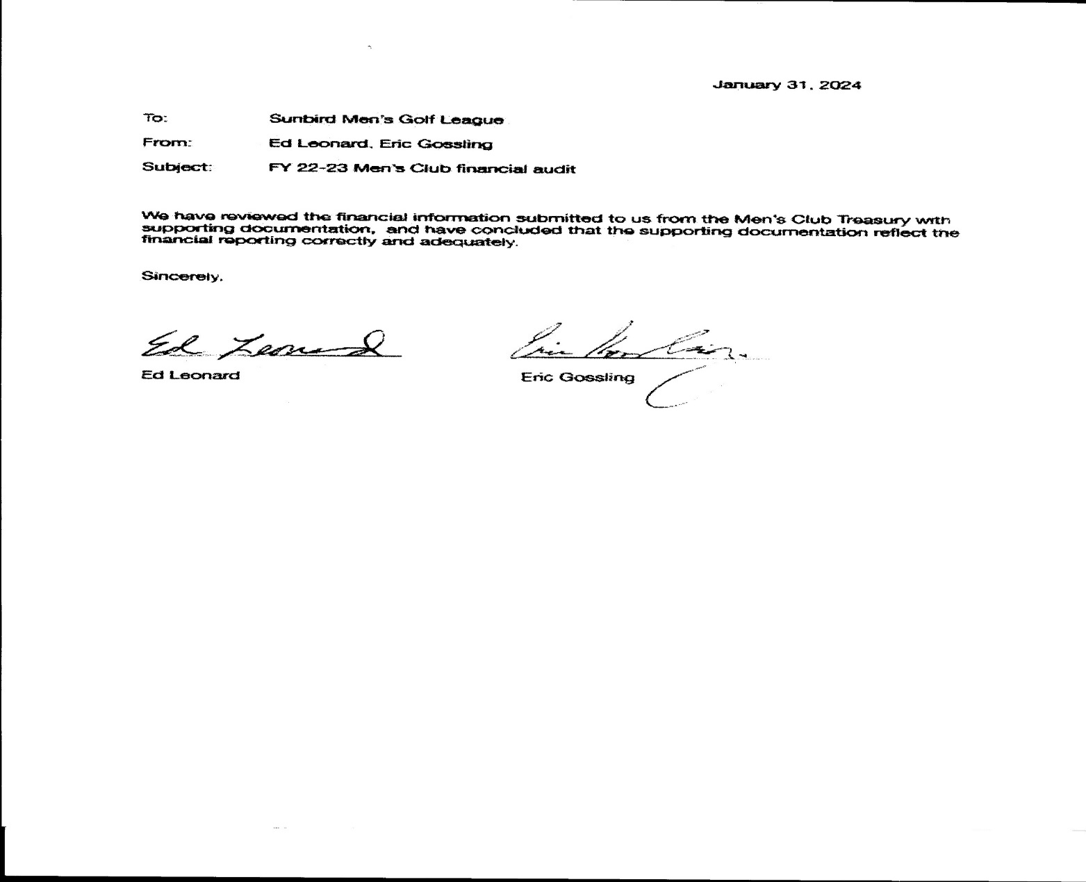

Summer League Schedule ‘24

May 9th 7:00 am Start Springfield GC

Contact: Rich Strozekski ($40)

Email: rich@springfieldgolfresort.com

June 13th 7:30 am Start Sunbird GC ($40)

Contact: Jack Cooper

Email: jacarl71@aol.com

July 9th 7:30 am Start Ironwood GC

Contact: Dan Smith 480-588-1832

Email: dsmith7018@yahoo.com

August 1st 7:30 am Start Sun Lakes GC

Contact: Rick Howell 480-244-9093

Email: rickhowell@pga.com

September TBD Palo Verde CC

Contact: Rich Kuhn 541-923-5568

Email:

Note: Sunbird cost for our members is prize money plus cost of food.
Outside play is $40 (target cost)

SUNBIRD MEN’S CLUB SCHEDULE 2023-2024

NOVEMBER 2023
7St Men’s Meeting 9:00 am – east end of Ballroom
9rd Gross-Net
16th 2 Man Scramble, Gross-Net
23th Thanksgiving Turkey Shoot
30th 2 Man Best Ball (Four Ball)

December
5th Men’s Meeting 9:00 am
7th 2 Man Chapman
14th Gross-Net
21st Stableford
28th Gross-Net

January 2024
2nd Men’s Meeting 9:00 am
4th 1-2-3 Net
11th First Round of Match Play
18th Gross-Net (First Net couples shoot out qualifier)
25th Gross-Net (Second Net couples shoot out qualifier)

February
1st Gross String Game
2nd Couples Net Shootout 2:00 pm
6th Men’s Meeting 9:00 am
8th 1st Round of club Championship and Sunbird Cup
15th 2nd Round of Club Championship and Sunbird Cup
22nd 2 Man Chapman
29rd Gross-Net/1st Qualifier for Couples Gross Shootout

March
5th Men’s Meeting 9:00 am
7th Gross-Net (Second Qualifier for Couples Gross Shootout)
14th Stableford
15th Gross Couples Shootout 2:00 pm
21st 2 Men Net Scramble (You pick your partner or we pick)
29th Combined Men’s/Ladies Step Aside Scramble, Lunch & Awards (No Play Thursday, 3/28)

April
2nd Men’s Meeting 9:00 am
4th Riggs Road Cup - April 4, 2024 at Sunbird
11th Riggs Road Cup - April 11, 2024 at Springfield
18th Gross-Net
25th Gross-Net
SUMMER SEASON BEGINS

